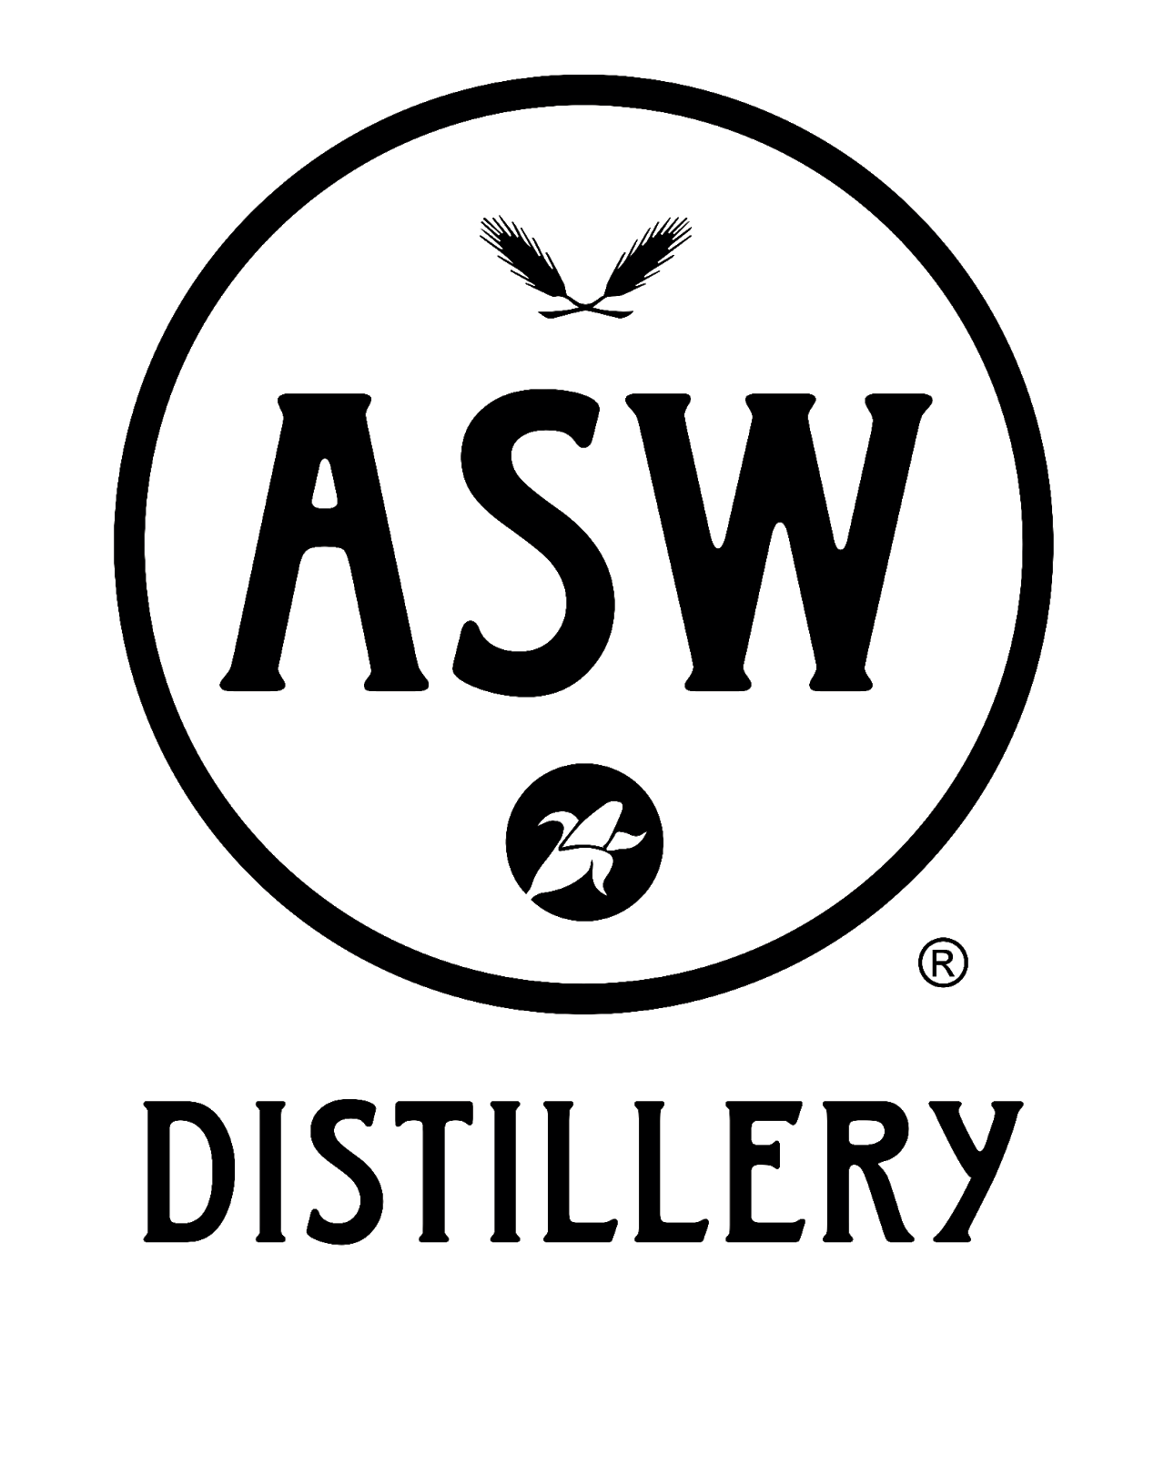

For more information:
Chad Ralston
ASW Distillery
678-592-5103
chad@aswdistillery.com

Hometown craft whiskey producer ASW Distillery opening at The Battery Atlanta, March 27
Tasting room and private events space offers a field trip for adults at the south’s preeminent lifestyle destination

ATLANTA (March 8, 2021) – The Battery Atlanta partners with the largest production distillery in Georgia to bring a third ASW Distillery to the Atlanta community. The new space, with its grand opening slated for March 27, features a tasting room, a Vendome copper pot/column hybrid still for distilling gin and vodka, a small batch bottling operation, the most extensive cocktail program of ASW Distillery’s three Atlanta locations and a large private events space in the former Häagen-Dazs space at The Battery Atlanta. ASW Distillery at The Battery Atlanta’s one-of-a-kind craft products and experiences will complement the table of tastes and experiences at the Cobb County lifestyle destination.

Jim Chasteen and Charlie Thompson started ASW Distillery in 2011; Justin Manglitz, a world-class master distiller, joined his fellow University of Georgia alumni in 2015. ASW was the first whiskey distillery in the City of Atlanta since the American Prohibition. To date, ASW has released Fiddler Bourbon, Resurgens Rye, and Tire Fire Single Malt, in addition to bringing the state its first-ever Double Gold Medal award for a whiskey with its Duality Double Malt and the 2020 Craft Whiskey of the Year in Maris Otter Single Malt Whiskey.

"The Atlanta Braves have been such an integral part of Georgia history for over fifty years. The state has likewise been home to a rich tradition in whiskey-making that we've been excited to help revive,” said Jim Chasteen, CEO of ASW Distillery. “Bringing these two rich traditions together – Braves baseball and Georgia distilling – is like a dream come true for us. We’re especially excited to have secured additional space at The Battery Atlanta that will allow us to host corporate and private groups for interactive experiences on game days and throughout the year."

“The opening of ASW Distillery continues to showcase the very best of what The Battery Atlanta brings to the market. The Braves Development Company is excited to welcome ASW to the heart of Braves Country – creating yet another uniquely curated experience for fans and guests,” said Jeremy Strife, Executive Vice President of Development. “ASW represents another hugely successful, local business whose products and brand reputation for demonstrating high moral character has earned the confidence and admiration of many Georgians and others throughout the southeast. Jim, Charlie, Kelly and their team were among the first Battery Atlanta merchant partners who immediately began supporting the local community during the pandemic by converting their operations to create hand sanitizer – their commitment to giving back while sacrificing their own financial benefit is another reason we are proud to welcome them to The Battery Atlanta team.”

ASW Distillery will offer The Battery Atlanta’s visitors public tasting hours from noon to 9 p.m. every day of the week and noon to 10 p.m. on game days, as well as walk-up tour experiences. The cocktail program will educate attendees on how to prepare whiskey cocktails and the history behind them. Known for its wide assortment of whiskies and numerous Double Gold Medals, Gold Medals and Craft Whiskey of the Year awards at the prestigious San Francisco World Spirits Competition, ASW will distill a new vodka, Bustletown Vodka, and gin, Winterville Gin, onsite at The Battery Atlanta.

Bustletown Vodka will be available during the grand opening event on March 27 at ASW Distillery at The Battery Atlanta. Seven-times distilled, ultra-filtered with activated carbon and made in small batches using choice cuts, Bustletown takes its name from Atlanta’s status as the busiest city in the South.

The 4,914 square-foot location, comprised of a 3,514 square-foot tasting room and 1,400 square-foot private event space, is located across from Good Game powered by TopGolf Swing Suite on the corner of Legends Place and Battery Avenue.

###

About ASW Distillery
As self-styled "Southern Spirits Pioneers", ASW Distillery is the 2nd most awarded craft distillery since 2018, as judged by the prestigious San Francisco World Spirits Competition. In crafting some of the most unique, small-batch whiskies in the country, ASW uses traditional, Scottish-style copper pot stills, but adds a Southern innovation by leaving the grains in throughout the entire process (grain-in distillation), rather than removing the grains before distilling, as happens with traditional single malts. They have three locations in Atlanta: their original distillery and tasting room in Buckhead; their barrelhouse and tasting room in the West End; and their brand-new distillery and tasting room at The Battery Atlanta.
For more information on ASW Distillery, please visit aswdistillery.com or connect on Facebook, Instagram and Twitter.

About The Battery Atlanta
The Battery Atlanta, a 2 million square-foot mixed-use development, located at the intersection of I-75 and I-285, offers an unmatched mix of boutique shopping, market-exclusive entertainment experiences, chef-driven restaurants, the Omni and Aloft Hotels, The Coca-Cola Roxy and 531 residences. The complex includes offices One Ballpark Center, Comcast’s regional headquarters; Two Ballpark Center, home to SPACES; Three Ballpark Center (opening 2021), which will serve as Papa John’s global headquarters and TK Elevator’s North American headquarters; and Four Ballpark Center. Powered by Comcast’s all-fiber network and delivering multi-terabit capabilities, The Battery Atlanta has the highest-capacity network serving any mixed-use development in the nation. For more information on The Battery Atlanta please visit batteryatl.com or connect on Facebook, Instagram and Twitter.

